Set up Docker

- Use AWS and create EC2 instance running Ubuntu (Compatible version ) at that time.

Cat /etc/*release* ------------> to list down the version in Ubuntu; Check the compatibility of displayed version with the docker documentation

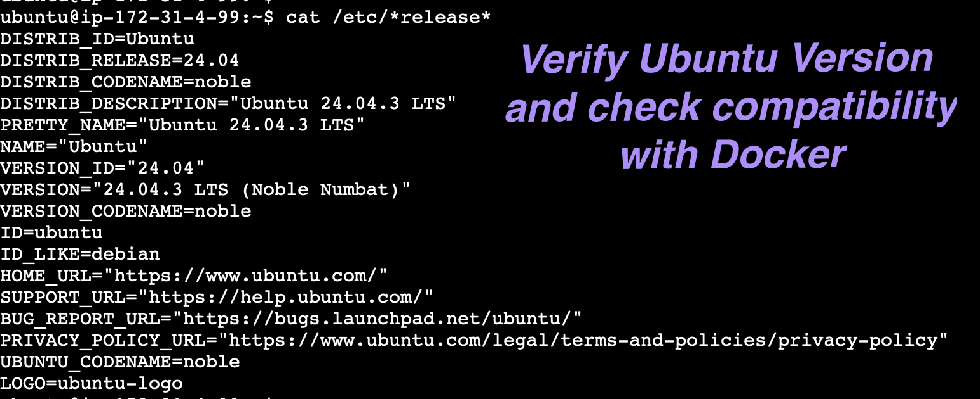

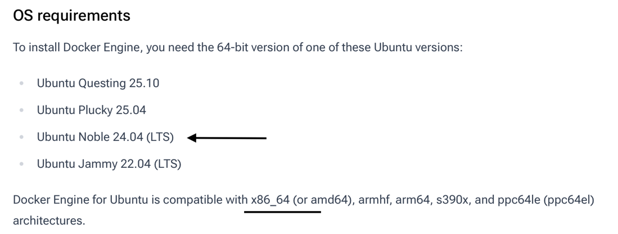

- Docker Documentation URL and set up steps.

https://docs.docker.com/engine/install/ubuntu/

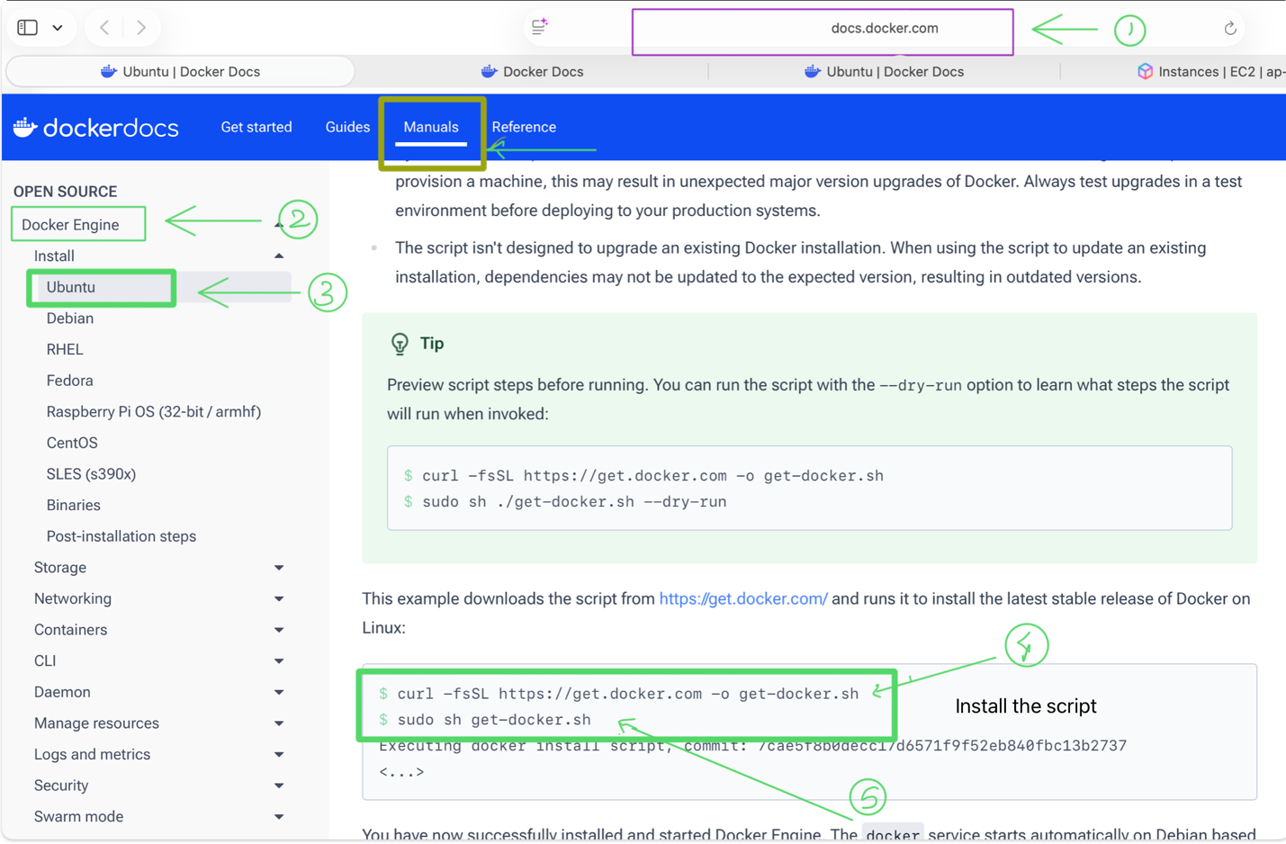

Note: The Docker service starts automatically after installation. To verify that Docker is running, use:

sudo systemctl status docker

Some systems may have this behavior disabled and will require a manual start:

sudo systemctl start docker

- Check Docker version

sudo docker version

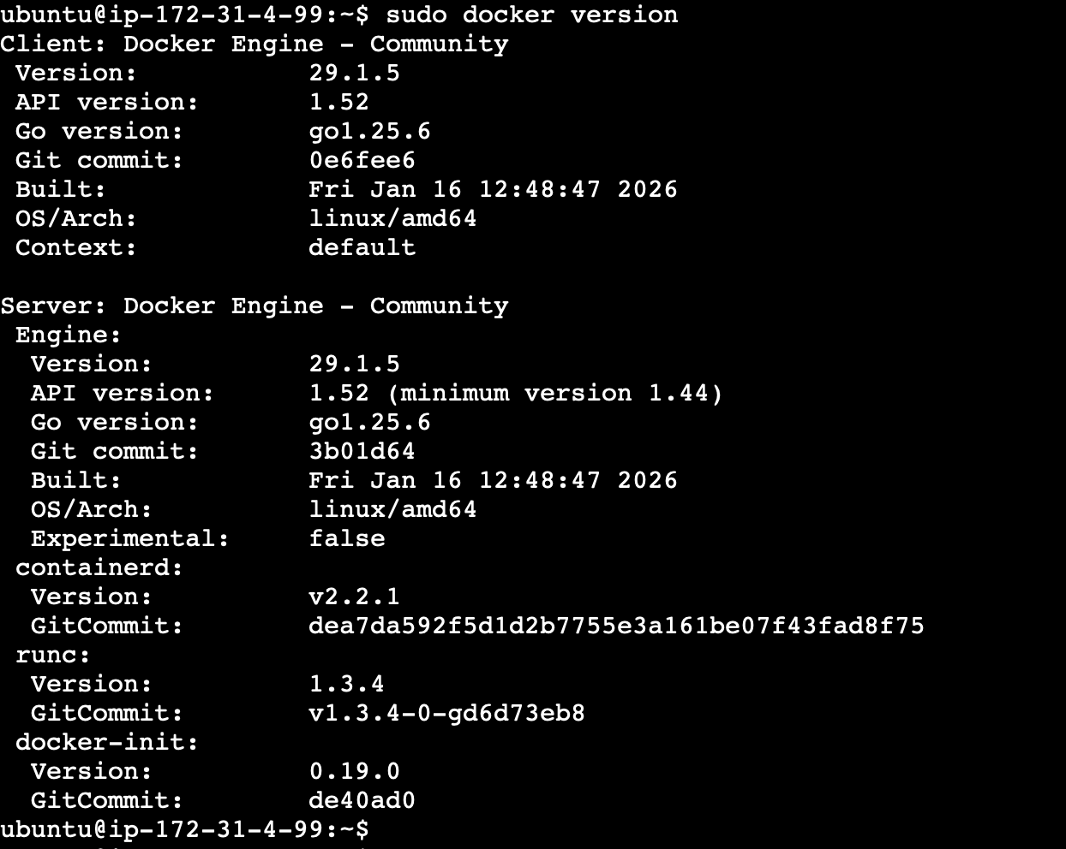

- Run a hello-world container.

Sudo docker run docker/hello-world

This may throw an error - as user ubuntu is not part of the group docker.

sudo usermod -aG docker ubuntu

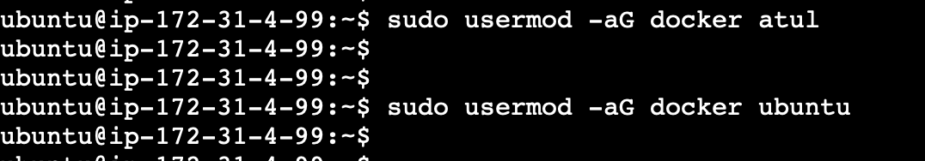

Now test docker access:

docker run hello-world

If you get a permission error again
It means the group membership hasn’t refreshed.
Run:
newgrp docker

Test again:

docker run hello-world

